Project Design Phase-II
Data Flow Diagram & User Stories

Date | 31 January 2025
Team ID | SWTID-2026-9795
Project Name | Streamlining IT Procurement: Automating Standard Laptop Orders with Flow Designer
Maximum Marks | 4 Marks

Data Flow Diagrams:
A Data Flow Diagram (DFD) is a traditional visual representation of the information flows within a system. A neat and clear DFD can depict the right amount of the system requirement graphically. It shows how data enters and leaves the system, what changes the information, and where data is stored.
Project DFD Level 0
Project DFD: Standard Laptop Procurement Automation
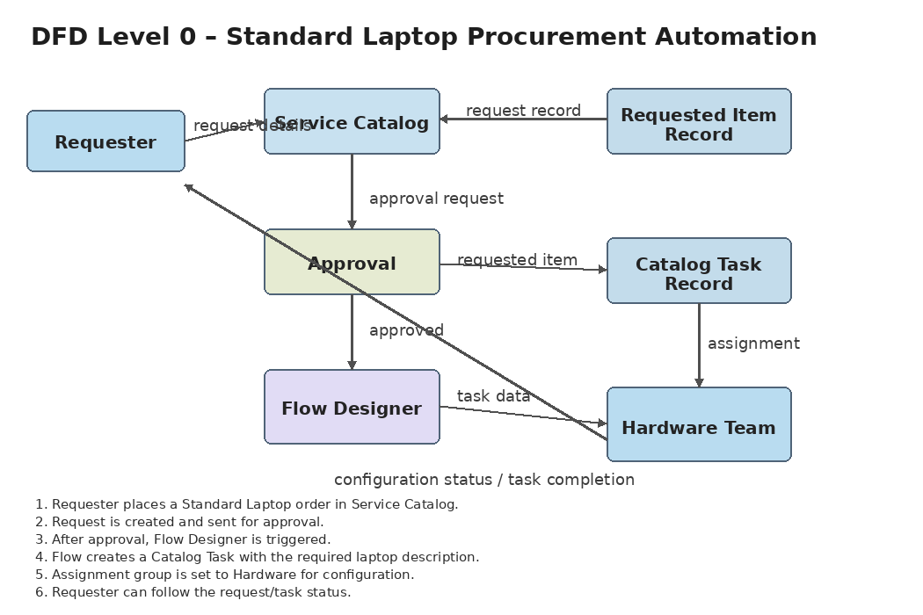

User Stories
Use the below template to list all the user stories for the product.
User Type | Functional Requirement (Epic) | User Story Number | User Story / Task | Acceptance criteria | Priority | Release
Requester | Standard Laptop Request | USN-1 | As a requester, I can open the Standard Laptop item and place a request. | A Standard Laptop request is created. | High | Phase-1
Requester | Standard Laptop Request | USN-2 | As a requester, I can submit the Standard Laptop request for approval. | The request enters approval. | High | Phase-1
Approver | Request Approval | USN-3 | As an approver, I can review and approve the Standard Laptop request. | The request shows Approved. | High | Phase-1
Requester | Request Tracking | USN-4 | As a requester, I can view the request and Requested Item records. | The records are accessible. | Medium | Phase-1
IT Procurement Team | Automated Task Creation | USN-5 | As procurement, I want an approved request to automatically create a Catalog Task. | A Catalog Task is created. | High | Phase-1
IT Procurement Team | Task Details Update | USN-6 | As procurement, I want the task description to state that the laptop needs configuration. | Required task details are present. | High | Phase-1
IT Procurement Team | Hardware Assignment | USN-7 | As procurement, I want the Catalog Task assigned to Hardware. | Assignment group is Hardware. | High | Phase-1
Hardware Team | Laptop Configuration | USN-8 | As Hardware, I can receive the assigned task and configure the laptop. | The task is available to Hardware. | High | Phase-1
Requester | Task Status Tracking | USN-9 | As a requester, I can view the related Catalog Task status. | The task and status are visible. | Medium | Phase-1
IT Administrator | Flow Assignment | USN-10 | As an administrator, I can assign and activate the Standard Laptop Task flow. | The catalog item uses the active flow. | High | Phase-1

